Hiyab Mengisteab
Analytics Programming — D598

KN1 Task 1: Program Planning

A. Flowchart for the Program

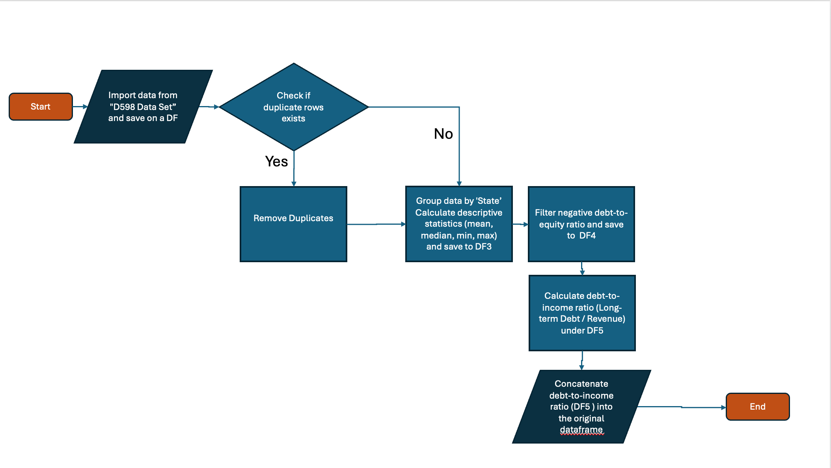

B. Pseudocode for the Program
1. START
2. Import data from "D598 Data Set" as df
3. Check for duplicate rows in df
IF duplicates exist THEN
Delete duplicates and save as df2
ELSE
Save original df as df2
4. Group df2 by 'Business State' and calculate descriptive statistics (mean, median, min, max), save as df3
5. Filter df2 for businesses with negative debt-to-equity ratio, save as df4
6. For each row in df2:
IF Revenue == 0 THEN
Set debt-to-income = 0
ELSE
Set debt-to-income = Long-term Debt / Revenue
Save result as df5
7. Concatenate df2 with df5 into df6
8. END

C. Explanation of the Relationship Between Flowchart and Pseudocode

1. Logic Behind the Flowchart and Pseudocode
- Both the flowchart and pseudocode are built to display the steps required to achieve the data manipulation requests and generate more meaningful insights. While the flowchart shows the logic in a visual display, the pseudocode translates the same steps into a text format describing the necessary steps that can be converted into programming language.

2. Alignment Between Flowchart and Pseudocode
- The flowchart and the pseudocode are aligned under each Action step sequentially.
Flowchart | pseudocode
START | START
Import data from "D598 Data Set” and save on a DF | Step 1: Import data from "D598 Data Set" as df
Check if duplicate rows exists?  Remove Duplicates | Step 2: Check for duplicate rows in df  IF duplicates exist THEN  Delete duplicates and save as df2  ELSE  Save original df as df2
Group data by 'State’  Calculate descriptive statistics (mean, median, min, max) and save to DF3 | Step 4: Group df2 by 'Business State' and calculate descriptive statistics (mean, median, min, max), save as df3
Filter negative debt-to-equity ratio and save to DF4 | Step 5: Filter df2 for businesses with negative debt-to-equity ratio, save as df4
Calculate debt-to-income ratio (Long-term Debt / Revenue) under DF5 | Step 6: For each row in df2:  IF Revenue == 0 THEN  Set debt-to-income = 0  ELSE  Set debt-to-income = Long-term Debt / Revenue  Save result as df5
Concatenate debt-to-income ratio (DF5 ) into the original dataframe | Step 7: Concatenate df2 with df5 into df6
END | END

Reference:
- External resources not used in this submission

